Samuel Ogunfunmi

Purpose: Solve problems using repetition

Date:10/5/2020

**Problem 1)**

**1. Algorithm (Solution Plan for the Problem):**

1. Create variables for running total and counting the number of times the loop runs
2. Create a function to find the average
3. Ask the user to enter a test score and save the input
4. Create a while loop and determine if the test score is a positive or negative number
5. Add to the running total and to the counting variable
6. Create a sentinel value that will end the loop
7. Find the average of the test scores that were entered
8. Print the average
9. Tell user if they have a passing or failing grade

**2. Program Source Code (copy and paste from IDE):**

def calcAverage(tot,count): #fucntion made to find the average of 3 numbers

avg = tot / count

return avg #Returns result of 3 inputs averaged to main

def main():

tot = 0.0

count = 0

#Priming Read

x = float(input("Enter a test score: ")) #ask user for input

while x >= 0: #Determines if user input is a positive or negative number

tot = tot + x #adds to running total

count = count + 1 #Adds to counter

x = float(input("Enter another test score (negative to quit): "))

avg = calcAverage(tot,count) #call variable from calcAverage function

print("\nThe tests score average is", avg) #Tells the user their test score average

if avg >= 70: #Determines if the user test score average

#results in a passing or failing grade

print("You have a passing grade.")

else:

print("You do not have a passing grade.")

main()

**3. Program Output Screenshots/Screen Print(s) and/or Error Messages:**

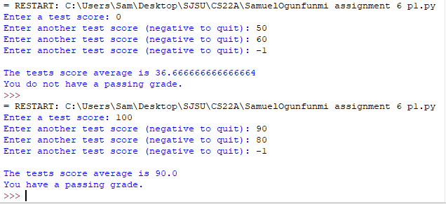

**Problem 2)**

**1. Algorithm (Solution Plan for the Problem):**

1. Create variables for running total and counting the number of times the loop runs
2. Create a function to find the average
3. Ask the user to enter a patient weight and save the input
4. Create a while loop and determine if the test score is a positive or negative number
5. Add to the running total and to the counting variable
6. Create a sentinel value that will end the loop
7. Find the average patient weight
8. Print the average

State Table

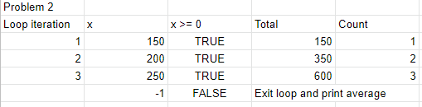

**2. Program Source Code (copy and paste from IDE):**

def calcAverage(tot,count): #fucntion made to find the average of the inputs

avg = tot / count

return avg #Returns result of the inputs averaged to main

def main():

tot = 0.0 #running total

count = 0 #running count

x = float(input("Enter patient weight: ")) #Ask user for test score Prime reading

while x >= 0: #Determine if input is a positive number

tot = tot + x #Adds new input to running total

count = count + 1 #Keeps track of the number of times loop is run

x = float(input("Enter patient weight(negative number to quit): "))

avg = calcAverage(tot,count) #Returning

print("\nThe average patient weight is ", avg)

main()

**3. Program Output Screenshots/Screen Print(s) and/or Error Messages:**

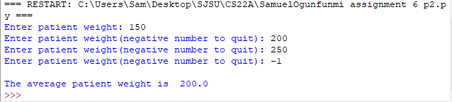

**Problem 3)**

**1. Algorithm (Solution Plan for the Problem):**

1. Create count variable and boolean variable
2. Ask user to enter a number for Prime Reading
3. Create while loop using boolean variable
4. Add to count total
5. Create if statement to determine if the input is in range, out of range, or is a negative number to end the program

State Table

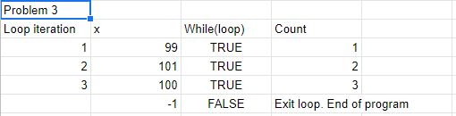

**2. Program Source Code (copy and paste from IDE):**

def main():

count = 0 #running count

loop = True #Boolean variable

print("This program validates inputs from 0 to 100\n") #Introduces program to user

#Prime reading

x = float(input("Enter a number (negative number to end program)\n Number: ")) #Ask user to enter a number

while (loop):

count = count + 1 #Keeps track of the number of times loop is run

if x >=0 and x <= 100: #Determines if input is in range

print("This number is in range\n")

if x > 100: #Determines what is too high of a number

print("ERROR! Number is too high. Try again.\n ")

if x < 0: #Identifies negative numbers and ends the loop

loop = False #ends the loop(break)

else:

x = float(input("Enter a number from 0 to 100(negative number to end program)\n Number: "))#Ask user to enter a number

print("\nThe End")

main()

**3. Program Output Screenshots/Screen Print(s) and/or Error Messages:**

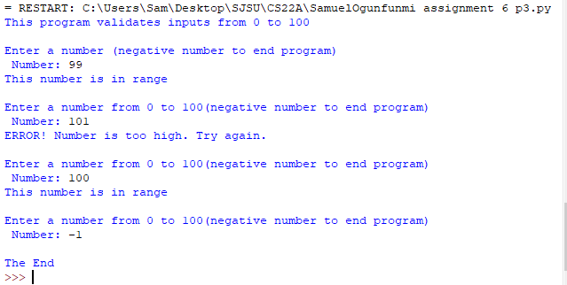

**Conclusion/What you learned writing this program and what problems you encountered.**

I learned how to use while loops to create a continuous loop, how to use sentinel values to end a loop, and how to use boolean variables in a loop. One problem that took a while to figuring out was how to use a negative value to end the loop.